**CITS3200 Group B**

**Minutes of Meeting 4 held on August 14, 2018**

Present:  Minrui Lu, Chen Liu, Michael Bleakley, Samuel Fairs, Lachlan Bunney

Apologies:  Joshua Milambo

Absent: None

Meeting Started: 1:00pm

|  |  |
| --- | --- |
| 4.1 Client’s General Layout Confirmation   * This project would be divided into three parts: front-end page, API, and database. * Client consents to use one database. * Three webpages for uploading questions, editing exam paper, and updating exam paper results. | ACTION  All |
| 4.2 File Uploading Part Discussion  All members summarize client’s requirements that:   * There should be a text box for users to copy the latex code in and generate the code into a file saved in database. * There should be a button to upload the question latex files. * There should be a button to upload images in respective questions. * There should two text boxes for users to type in the topic and subtopic of the question uploaded.   Minrui indicates that:   * Webpage should remind users that preview image should be included when they are uploading files. * There should be a default preview image revealing that no question preview available if user did not upload the preview.   Sam indicates that:   * We should negotiate with the client, persuading him that putting latex code in the text box and generate a text file would be difficult.     4.3 Editing Exam Paper Part  All members summarize client’s requirements that:   * When generating all questions into an exam paper, in each question’s code, referred images’ names should be changed in case of reference collision.   Michael and Lachlan indicate that:   * Writing a code to change the image name in latex files and guaranteeing no collision is not practical. Users should change the referred image names manually before they upload the files. * In the question cart, user should be able to decide which questions should be printed in the paper and which should be discarded. Associated question history should be added to the database.   Sam indicates that:   * Webpage should be able to save each user’s chosen question.   4.4 Updating Result Part  All members summarize client’s requirements that:   * This webpage should provide users a text box or drop box to choose targeted exam paper. * After clicking into an exam paper, there should be an interface to input all question correctness results and notes for each question.   4.5 Date of Next Meeting  1-2pm, August 17th, Physic Building | All  Minrui      Sam        Michael and Lachlan    Sam        All          ALL |

Meeting Closed: 2:00pm

**Attachment:**

Idea drafts from the client John Brooke.

**Draft 01:**

Uploading File webpage interface thought.

Description of Updating Result webpage thought.

Database tables idea.

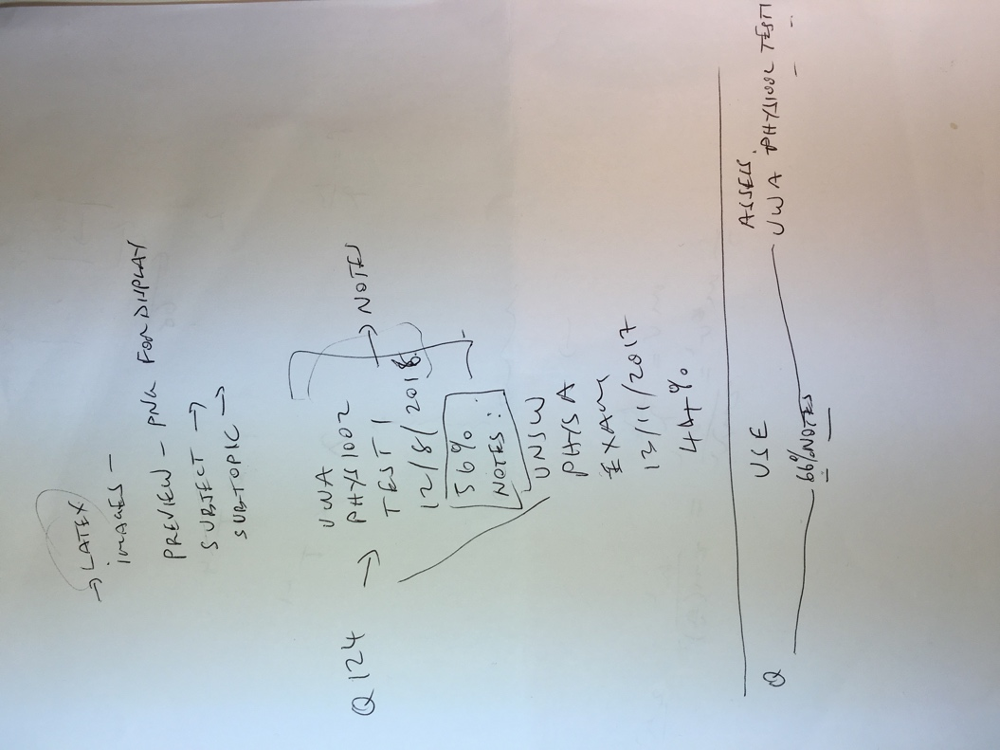

**Draft 02:**

Idea of Updating Results webpage interface.

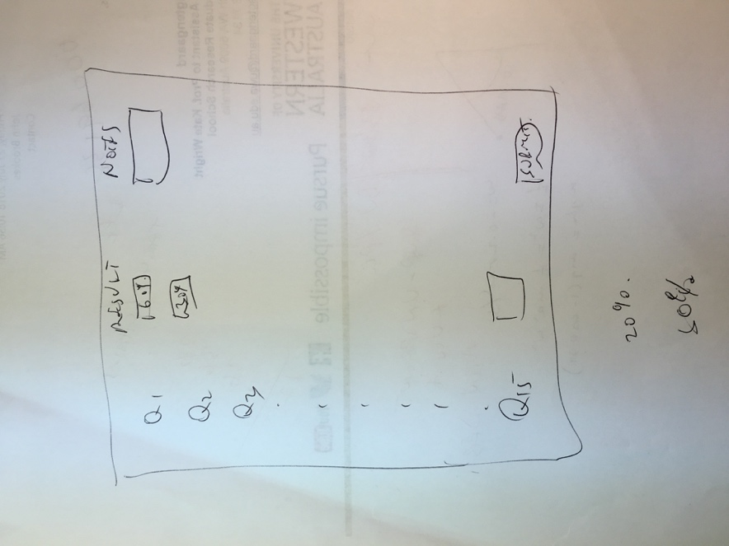

**Draft 03:**

Idea of project general layout.

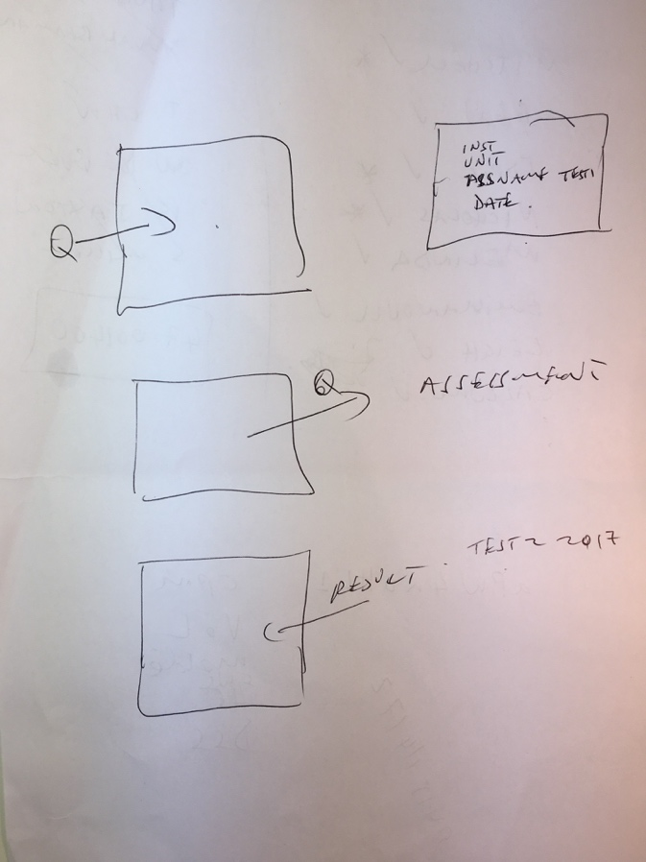

**Draft 04:**

Idea of Uploading File webpage interface.

